Biosignal recognition training tool

Anzhelina Andriyanova and Angèle Umba

Supervisor: Prof. Dr. Paul Devos

Academic year: 2017 – 2018

Content table

Introduction 1

Program: C# 1

Layout 2

Main window 3

Tabs 3

Training 3

Learning 5

Exam 6

Add 7

Database 8

Future work 9

Appendix 11

1. Images of the main window 11

2. Images of the training session 13

3. Images of the learning session 15

4. Images of the exam session 16

5. Images of the add tab 18

Introduction

The goal for this project is to create a training tool to gain the knowledge of heart- and lung sounds. The user will have the possibility to become familiar with several sounds of normal and abnormal hearts and lungs due to a program in C#. A database which contains the basic characteristics of the wav-files is integrated in a WPF-application. The graphical properties are stored in a xmal-file while the logic linked to the design can be found in the xmal.cs-file. The corporate identity of UGent was used as a reference to decide which colors and font-family to implement.

There are four tabs available once the application is launched: training, learning, exam and add. Each of those tabs are sessions which provides their own functionalities.

Program: C#

As mentioned before, WPF-application is used to accomplish the goal of this project. WPF stands for Windows Presentation Foundation which is Microsoft’s latest approach to create a graphic user interface (GUI). This allows you to dynamically use a wide range of GUI elements as textboxes, buttons, etc. These elements can be modified in a .xmal-file. A preview of how your GUI will look like gets refreshed every single time you change something in this file. To make those elements interact with each other or other xmal-files, a xmal.cs-file is linked. All the logic can be stored in there to make the application operational.

This project contains four xmal-files and equally as many xmal.cs-files. These have been implemented separately to create a distinct separation between all the tabs.

The main window serves as an entry to all the different tabs. A START-button has been linked to three of the four tabs, and a HOME-button will do the exact opposite. Tab ***Add*** doesn’t have a separate xmal-file because the corresponding logic is minimal.

All the implemented tabs will be describes thoroughly and illustrated in the next sections.

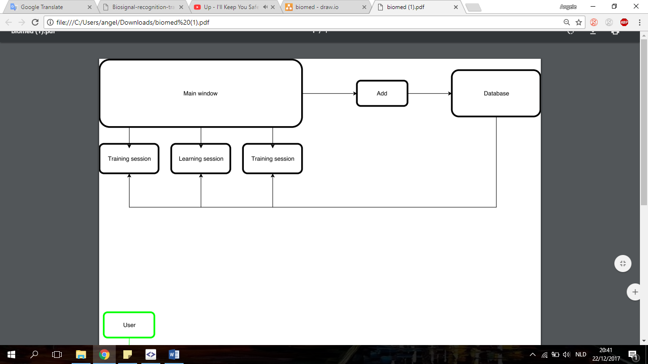

Figure 1: a block diagram of our project

Layout

To make this application user-friendly, it’s important for the layout to be structured. The GUIs can be decorated in different colors for that matter or placed on a blank space on the window. Because the implementation of the colors and the alignment is straightforward, only grid definition will be described based on figure 2. The exact height and width is described together with the title of the xmal-file. In this case has a height of 350 and width of 525 which results in a rectangle. Taking this in consideration, the second step is to define the desired amount of columns and rows. In this case three columns and two rows are picked. Each column can only have a width as a row can only have a height. The asterisk next to the number to give the width and height a specific value denotes the fact that every column and row have a relative width/height. So a width of 4* is equal to:

$\frac{525}{(4+5+4)} x 4=40,38 x 4=161,54$

The same logic applies on the rows. Now, to place a GUI element somewhere, stackpanels are created to pick a smaller rectangle from the main rectangle characterized by the defined columns and rows. For example, the stackpanel defined in figure 2 is the rectangle 1.

|  |
| --- |
| …  Title="Exam" Height="350" Width="525">  …  <Grid>  3  2  1  …  <Grid.ColumnDefinitions>  <ColumnDefinition Width="4*"/>  <ColumnDefinition Width="5*"/>  6  5  4  <ColumnDefinition Width="4*"/>  </Grid.ColumnDefinitions>  <Grid.RowDefinitions >  <RowDefinition Height="*"/>  <RowDefinition Height="4*"/>  </Grid.RowDefinitions>  …  <StackPanel Orientation="Vertical" Grid.Column="0" Grid.RowSpan="0" VerticalAlignment="Center">  …  </StackPanel>  …  </Grid> |

Figure 2: The way a window gets structures by using the grid

This method has been used to place all the GUI elements on the windows to create a pleasing view.

Main window

This window can be considered as the general input of this project. Not only is this the entry to the different xmal- and xmal.cs-files, but also a way to enter other wav-files in the database that is available at the launch of this application.

The windows of all the possible tabs are shown in appendix 1 from up to bottom. Each tab except the ***add*** tab contains a button and a text block. To initiate those tabs in the main window, a snippet of the code is shown in figure 3.

|  |
| --- |
| <TabControl Background="White">  <TabItem Header="Training" Background="LightSkyBlue">  …  </TabItem>  <TabItem Header="Learning" Background="LightSkyBlue">  …  </TabItem>  <TabItem Header="Exam" Background="LightSkyBlue">  …  </TabItem>  <TabItem Header="Toevoegen" Background="LightSkyBlue">  …  </TabItem>  </TabControl> |

Figure 3: Code of the xmal-file to implement the several tabs in the main window.

An introduction is given while residing on a specific tab to prepare you to start a session.

Tabs

This project provides different learning experiences which are integrated in the three tabs described below. The training session creates the opportunity to become familiar with the different heart and lung sounds which are fetched from the database. Secondly, the test session fabricate a concatenation of four sounds, four times in a row in a random sequence as a multiple choice test. Lastly, there is an exam session where one can test their skills by writing the abnormalities of the heart sounds that are playing in the background.

To view the several windows, there are images available in the appendix.

Training

This session provides an opportunity for the user to become familiar with the sounds provided to broaden the current knowledge on the recognition of several biosignals.

The window shown at the top image in appendix 2 is the first one seen once the training session is started. The first heart sound in the database is set as a default value to prevent errors once the play button is pressed. Besides playing the sounds that the user picked, there is also an opportunity to pause, stop and regulate the volume as desired.

A combobox linked to the database shows the selection of the sounds which were inserted, seen on the middle image in appendix 2. Whenever the timespan continuously changes its value, it’s an indication that there is a sound that’s playing as seen in the bottom image.

Using the variables implemented in the xmal-file of the training session seen in figure 4, functionalities can be linked to each action.

|  |
| --- |
| <MediaElement Source="C:\Users\angel\Documents\biomedische\Biosignal-recognition-training-tool\WpfApplication1\Heart sounds wav\001. Normal Heart Sound- normal speed.wav" Name="myMediaElement" Width="50" Height="50" LoadedBehavior="Manual" UnloadedBehavior="Stop" Stretch="Fill" MediaEnded="Element_MediaEnded"/>  …  <ComboBox Name="KeuzeSound" SelectionChanged="KeuzeSound_SelectionChanged" Width="200" Height="30" SelectedIndex="0">  …  <Label Name="lblStatus" Content="Not playing..." HorizontalContentAlignment="Center" VerticalContentAlignment="Center" Margin="5" />  …  <Button x:Name="btn1" Content="Play" Click="ButtonPlay" Width="100" Height="30" Background="LightSkyBlue" />  <Button x:Name="btn2" Content="Pause" Click="ButtonPause" Width="100" Height="30" Background="LightSkyBlue"/>  <Button x:Name="btn3" Content="Stop" Click="ButtonStop" Width="100" Height="30" Background="LightSkyBlue"/>  <TextBlock VerticalAlignment="Center" Margin="5" >Volume:</TextBlock>  <Slider Name="volumeSlider" VerticalAlignment="Center" ValueChanged="ChangeMediaVolume" Minimum="0" Maximum="1" Value="0.5" Width="70"/>  … |

Figure 4: Code of the xmal-file to implement the general functionalities in the training session

Due to a reused logic of the way sounds can be manipulated, a breakdown of how it happens will be described in this section.

The few variables used to do so is ***myMediaElement, KeuzeSound(_SelectionChanged), lblStatus, ButtonPlay, ButtonPause, ButtonStop*** and ***VolumeSlider***. Their functionalities goes as follow:

* ***myMediaElement***: the current sound that’s playing in the background represent this variable. It’s the name given to the GUI element responsible to handle sounds files.
* ***KeuzeSound***: the specific sound picked in the combobox. This is linked to a path to the database
* ***KeuzeSound_SelectionChanged***: this reallocates the path of the sound whenever another sound is picked from the combobox.
* ***lblStatus***: this projects the timespan of the sound by continuously checking whether the sound is playing. The timespan increments by the second as long as the pause or stop button is not pressed.
* ***ButtonPlay***: the on click action linked to the play button. By pressing this, the timer starts together with the sound and increments the timer (projected on the lblStatus) until the end of the sound (or the other two buttons are pressed)
* ***ButtonPause***: pauses the sound and freezes the timespan
* ***ButtonStop***: stops the sound and resets the timespan
* ***VolumeSlider***: alters the volume by choosing a minimum, maximum and default value. Ours is set right in the middle.

Inherent libraries were used to implement these variables were used to execute these functionalities.

To terminate this training session, it’s sufficient to click on the home button to be brought back to the main window to access other sessions.

Learning

In this session the user needs to recognize one sound among a mix of 4 sounds, 4 times (16 sounds), point it out and submit it. Right after that, the correct answer gets projected immediately after submitting their choice. Only if the correct answer is submitted, another set of mixes gets prepared and other answer possibilities. This can go on as long as the user wish for and can be closed when pressing on the home button.

The first image in appendix 3 is the first view of the learning session. Compared to the previous session, a few GUI elements were kept the same (the timespan and the volume slider). Actually, the four option buttons can be considered as play buttons, but instead of one song there are a mix of 4 songs created. The mix are different sounds concatenated after one another. On figure 5 there is an implementation in the layout of the significant essentials of this session.

|  |
| --- |
| …  <Button Width="100" Height="30" Background="LightSkyBlue" Click="Button_Click">Submit</Button>  …  <Button x:Name="btn4" Content="Keuze 4" Click="Button_Click4" Width="100" Height="30" Background="LightSkyBlue"/>  <ComboBox Name="cbAntwoorden" Width="100" Height ="30" Background="LightSkyBlue" SelectionChanged="ComboBox_SelectionChanged" SelectedIndex="0" ></ComboBox> |

Figure 5: Code of the xmal-file to implement the general functionalities in the learning session

The mixes are produced on the occasions: at the start of this sessions and after submitting a good answer checked by the function ***CheckAnswer***. Therefore it is necessary to implement the function ***MixingSongs*** in ***GenerateNextQuestion***. What these function do in detail is the following:

* ***MixingSongs***: this function is creating the mixes, firstly it generates 16 different random numbers between 0 and 104. That will be used to select the sounds from the database which should be mixed. It generates one more integer which is for selecting the right answer in one of those mixes and three integers which are numbers between 0 and 104 that will serve as the wrong answers (the numbers are distinct and created so that they will not be selected of the sounds in the mixes itself).The selected sounds will be added in a list of files with their paths, then we will produce four sound files by cutting it. The merging of the different sounds is placed in a different class named WaveIO. That class will basically place the headers of the wav files correctly and process the data of each wav file.
* ***GenerateNextQuestion***: this is going to run the previous function once.
* ***CheckAnswer***: the answer picked in the combobox ***cbAntwoorden*** is compared with the correct answer. If this is not the case, a messagebox will pop on the screen as seen in the second image in appendix 3. This will contain the right answer. If the correct answers has been submitted, ***GenerateNextQuestion*** will be generated and the default value of the combobox will be set on the first possible answer for the next question.

Now how does the submit button function? And what is so different on the option buttons compared to the standard play buttons? The on click actions are ***Button_Click*** and ***Button_Click4*** for the fourth option (the last number varies depending from which button it’s linked to).

* Button_Click: Not only does this action generate ***CheckAnswer***, but it also serve as stop button. The source of the sound also gets reset to prevent conflicts between two sounds.
* Button_Click4: the difference with a normal play button is that the source of the sound get set to the right location created by the function ***MixingSongs***.

Liked mentioned before, this sequence of creating mixes and answering continues up until the home button is pressed. After challenging your knowledge by repeatedly taking these tests, it’s time to try the exam session.

Exam

In this tab the student can perform a sort of examination. As soon as this session is started you will see the lay out as shown in the first figure of the fourth section in the appendix below. This project did the exam by mixing a sound which the user then can listen to. From this sound the user needs to recognize the type of the sound (Heart or lungs) and the abnormalities (if they are present). The mix consists, as in the learning session, of four sounds which are placed one after the other. The difficulty level is randomly chosen here, since there are sounds which are slowed down or speeded up. The play button will start to play a sound which is given for that question (by mixing or specifying a wav). To be able to have different answers there is an implementation of a question class which consists of five strings with the different partial questions, or an array of stings (right now implemented) or five answers strings and a sound path. The constructor of this class will set the questions and answers for every partial question, the sound path is given to make sure that the sound and the questions about it are linked. In the session itself we have a structured lay out as seen in figure 6. The questions will be filled in the labels as text and the answers can be given in the textbox below that label. If taking into the account that the questions are dynamic you need five partial questions for each element of the list.

|  |
| --- |
| …  <Label Name="lblq1" Content="Type:"/>  <TextBox Name="tbxQ1" />  …  <Button Name="btnNext" Grid.Column="3" Grid.RowSpan="2" HorizontalAlignment="Center" VerticalAlignment="Center" Content="Volgende" Click="btnNext_Click" Width="100" Height="30" Background="Yellow"/>  … |

Figure 6: Code of the xmal-file to implement the general functionalities in the exam session

The session implements the following methods:

* ***settingOfTheQuestions***: this method sets the right values into the question list. The list consists of multiple questions and stored respectively. The answers given by the user is stored in another array which makes it easier to grade the session.
* ***settingTemplate***: This function takes a number as input and will set the labels to the partial questions of that list item with index which is taken as input.
* ***checkingAnswers***: the following method is used to grade the question. The input of the user is directly compared to the answers set to that question.
* ***MixingSongs***: is the method which is also explained in the learning tab is here implemented too generate sound files for the question. Here it is chosen to ask for the type of the sound and the type of abnormality, which also is the reason that the type and the abnormality is set to the answers array in the mixing itself.
* ***btnNext_Click***: is called upon when the user goes to the next question. The previous methods will be called upon here too to generate the next question and setting it. Before that the mix is prepared so that the question itself has a unique sound. It may be that is some mixes the sounds which were previously used do occur. It clears the text boxes and sets the next questions, also here is checked whether or not it was the last question of the exam. When finishing the last question the correct answers will be displayed, and the total score will be shown to the user afterwards.

The other methods which are implemented are described in the learning session, the play button, pause button and the stop button. The functions handles the on clicks as previously mentioned. If the user would use the Home button, he quits the exam session what will result in no grading of it. The answers to the questions will be shown in message boxes which will pop up separately and so provide the chance to separately study the answers one by one. The score was chosen uniformly, which results in every correct answer given one point. So for every question the user can gain five points when the answers are given correct. After finishing a whole exam which now consists of four questions and their review, the user is prompted back to the main window and the examination session closes of here. The user can make another exam right after or decide that more learning is necessary beforehand. The exam can be logged but needs an extra function for that, the user answers are set one after the other just as questions which could be written in a text file with the time the user submitted that question.

Add

The next tab which is discussed here, doesn’t have an own session and the logic which will be used here, will be applied from the main window and the methods there. The layout of this tab can be found in the appendix under number five. The structured interface which will be displayed is showed in figure 7.

|  |
| --- |
| …  <TextBox Name="txtbxId" Width="130" Height="30"></TextBox>  <TextBox Name="txtbxType" Width="130" Height="30"></TextBox>  <TextBox Name="txtbxAfwijking" Width="130" Height="30"></TextBox>  <TextBox Name="txtbxLocatie" Width="130" Height="30"></TextBox>  …  <Button HorizontalAlignment="Right" Name="saveButton" Click="saveButton_Click" Width="100" Height="30" Background="Yellow">Save changes</Button>  …  <DataGridTextColumn x:Name="idColumn" Binding="{Binding Id}" Header="Id" Width="SizeToHeader"/>  <DataGridTextColumn x:Name="typeColumn" Binding="{Binding Type}" Header="Type" Width="SizeToHeader"/>  <DataGridTextColumn x:Name="afwijkingColumn" Binding="{Binding Afwijking}" Header="Afwijking" Width="SizeToHeader"/>  <DataGridTextColumn x:Name="locationColumn" Binding="{Binding Locatie}" Header="Location" Width="SizeToHeader" />  … |

Figure 7: Code of the xmal-file to implement the general functionalities in the add tab

The binding describes which column of the database will be displayed upon that place for each row that the database has. In the main window the element is bound to it by setting its source as soon as the element is loaded. The textboxes above that are there too receive user input, and when clicking the save button it will be saved in the database. When that button is clicked the text in the boxes will be inserted into the insert query which adds another row to the database. Since adding that row is not yet displayed we will update the database and fill our dataset with it again. Now the addition is complete and visible. The table adapter gives us the chance to update the data here too, yet we chose not to implement that because of the integrity of the files.

Database

We are using a local database for now which is an mdf file, our app connects too it automatically the structure of which can be seen in figure 8. There you can also add files manually which instantly sets them into the database. We use the dataset for it.

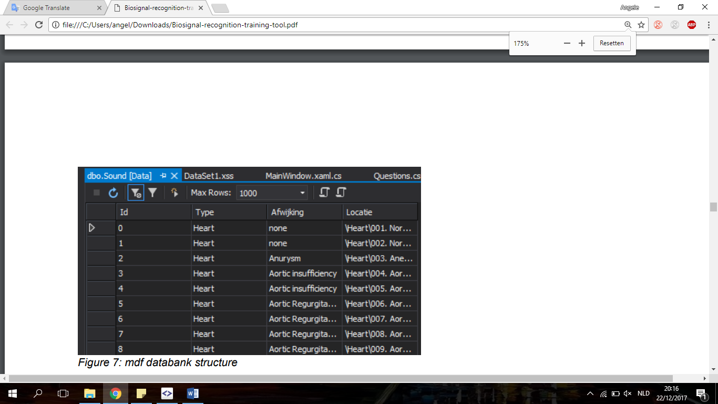

Figure 8: mdf databank structure

The visualization of that database can be seen through the designer of the dataset (which can be seen in figure 9) which is also created with the app. It displays the tables and their values which the database contains in our application through the adapter.

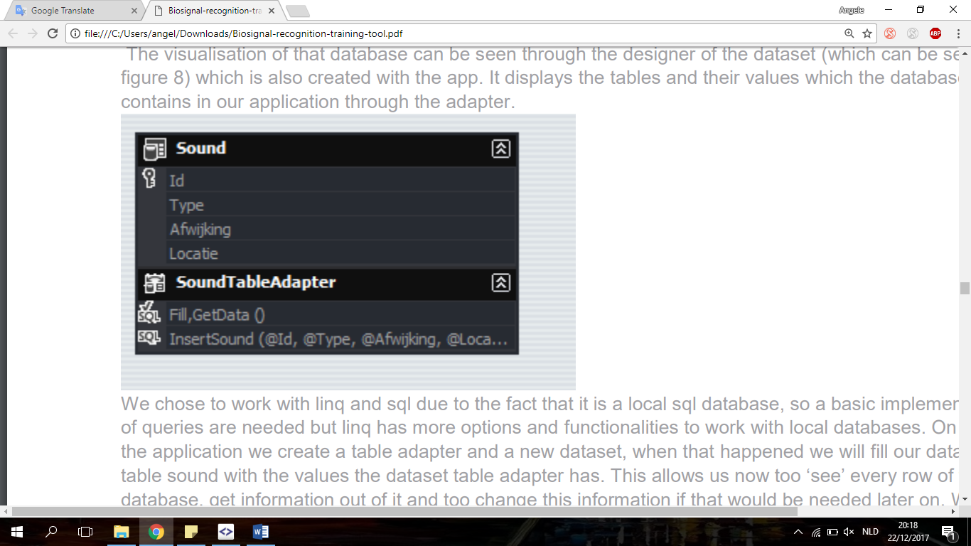

Figure 9: The visualization of the database

We chose to work with linq and sql due to the fact that it is a local sql database, so a basic implementation of queries are needed but linq has more options and functionalities to work with local databases. On start of the application we create a table adapter and a new dataset, when that happened we will fill our dataset table sound with the values the dataset table adapter has. This allows us now too ‘see’ every row of the database, get information out of it and too change this information if that would be needed later on. We have implemented our own insertion method with the capability of passing the values we want in the right columns dynamically. The addition of methods can be written here and added to the Adapter which allows us to call upon them when needed. In the Tabs Add was already explain how we use this method, yet the fact that the application needs to be fully reset to see that the data is permanently added to the database itself is mentions worthy. The moment we add data too it we will be able to see it visually on the tab of addition. But if we change tabs, go to another session and then later on return to the tab of adding data our last edited values will not be up to date. This is due to the fact that in an open connection the dataset is not changed, even if the data in the database itself did change.

Future work

A complete description of our project is given step-by-step in the previous sections. The front and back end result in a functioning program ready to be used. However, realistically speaking, there is always room for improvement. This can apply on the learning possibilities and the database by altering the basic structure.

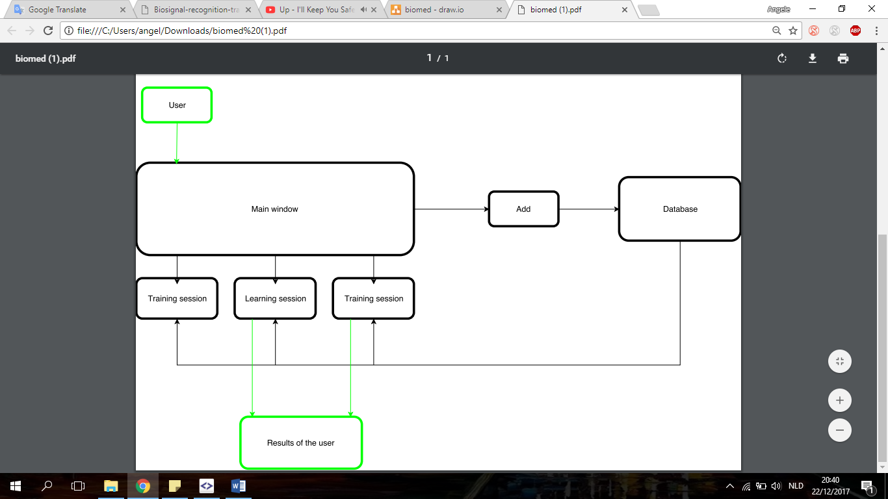

Figure 10: A block diagram of the potential improvements of this project

A major addition to this project is to provide a login which can produce some report of the performances on the student who is using this program. Based on the username and the password that has been inserted, a corresponding score can be translated into a log file to track the evolution of the skill over time. In an environment where a teacher uses this tool to aid the education, it might be quite necessary to add this possibility.

Also, due to a lack of knowledge of the abnormalities of heart and lungs, only a few columns were given to safe the sounds. This might be expanded by other properties as the severity of the illness or other medical terms. The added values might be supported by an addition of buttons on the several windows or text fields to create the ability of different types of questions. However, doing this in the backend is supported by the class that gives you the opportunity to add some questions.

Appendix

1. Images of the main window

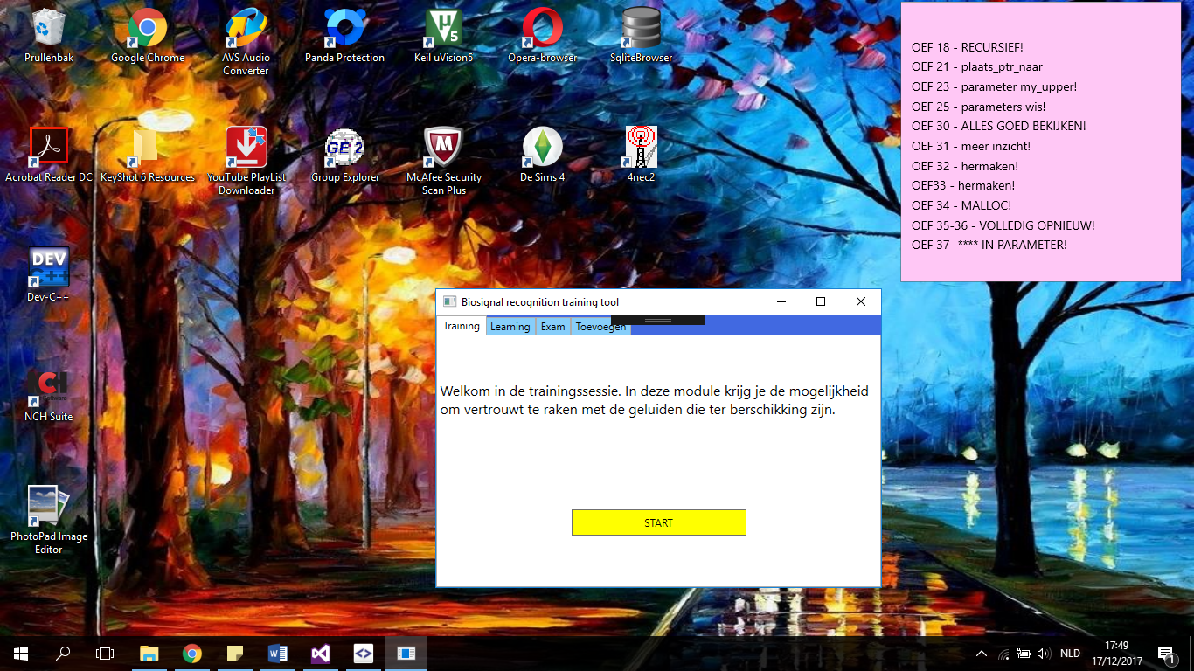

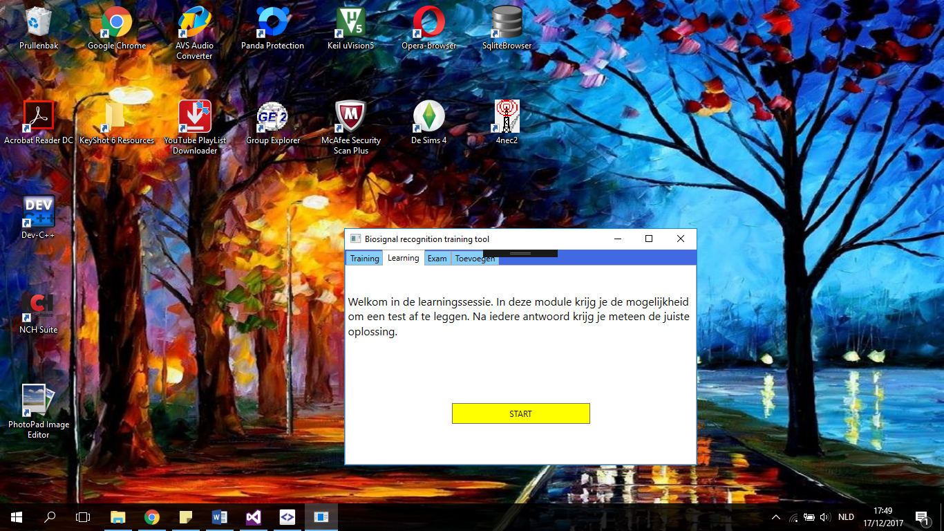

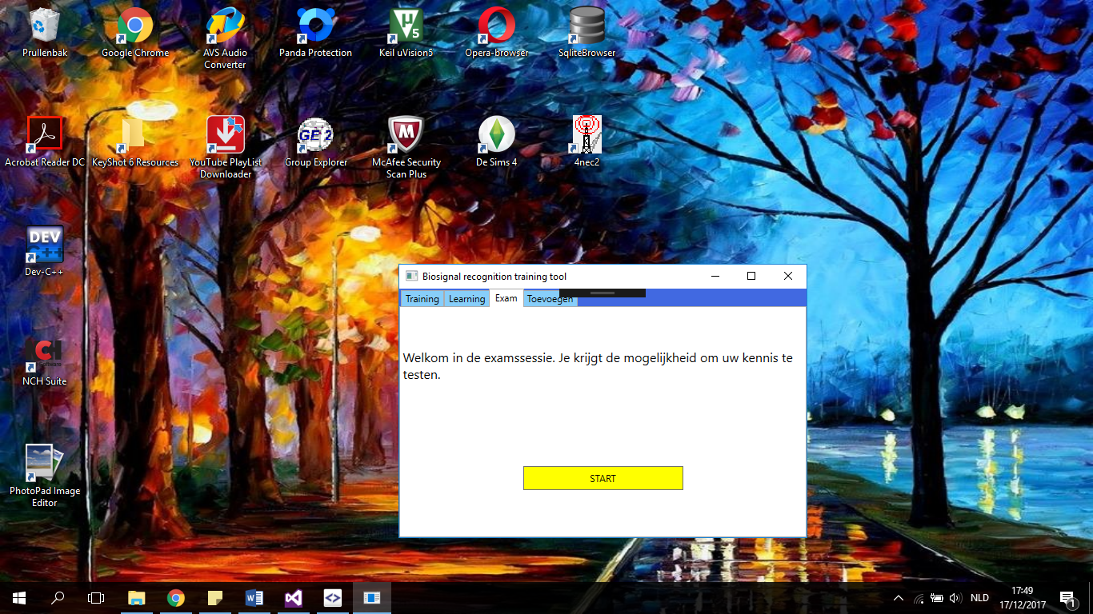

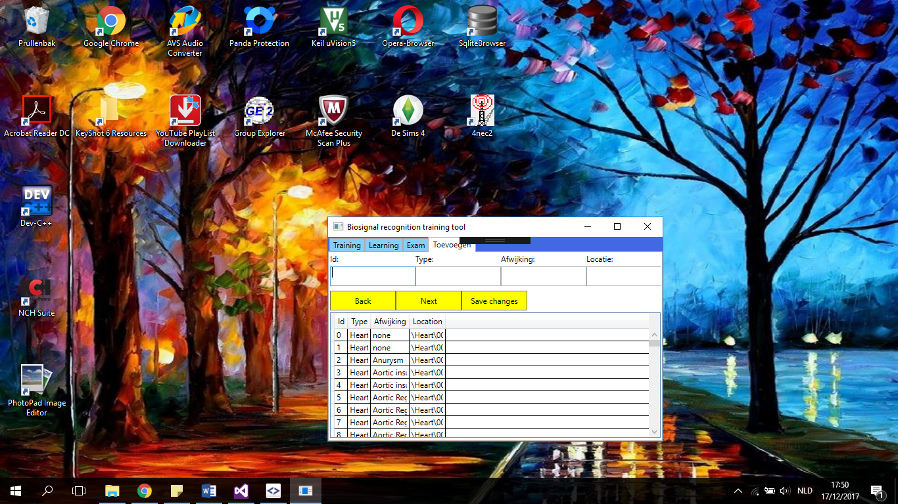

1. Images of the training session

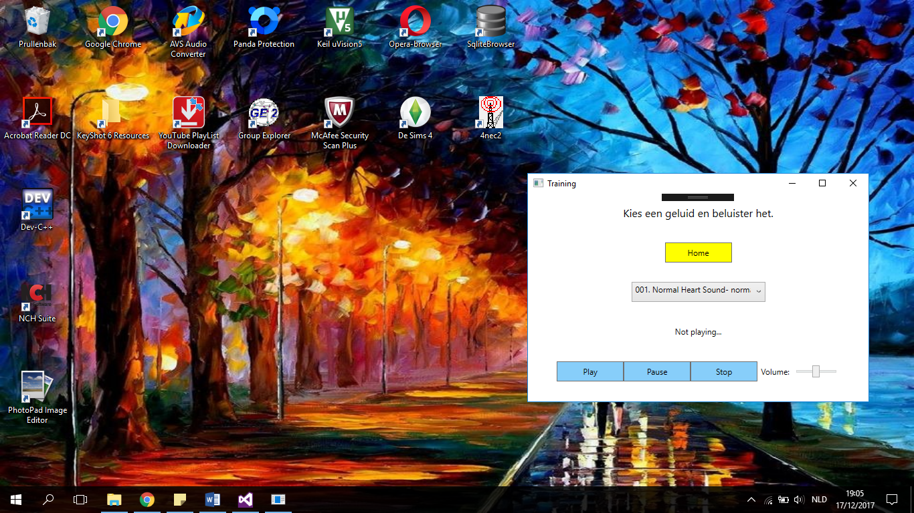

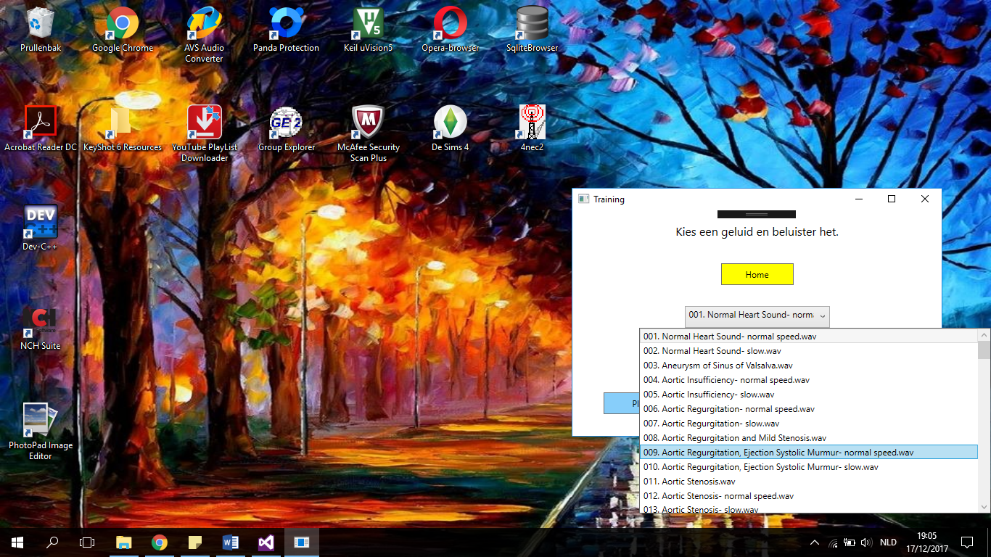

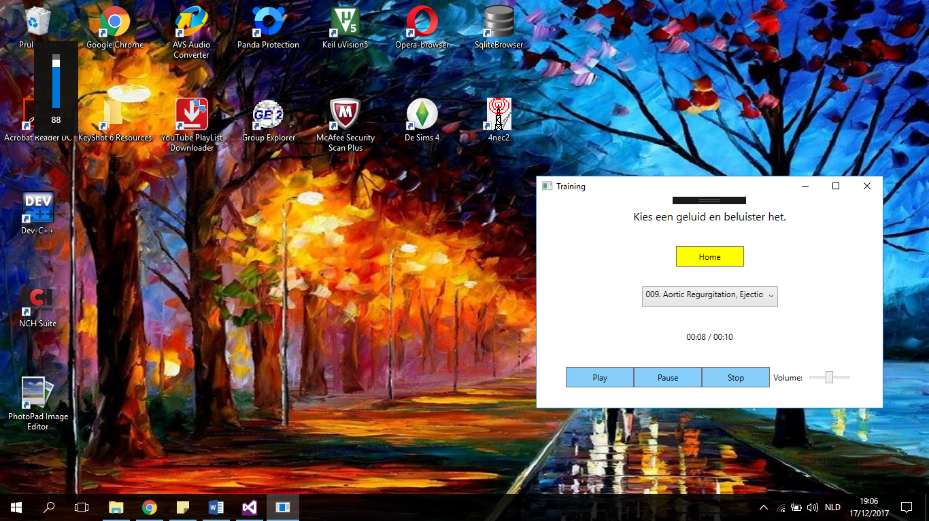

1. Images of the learning session

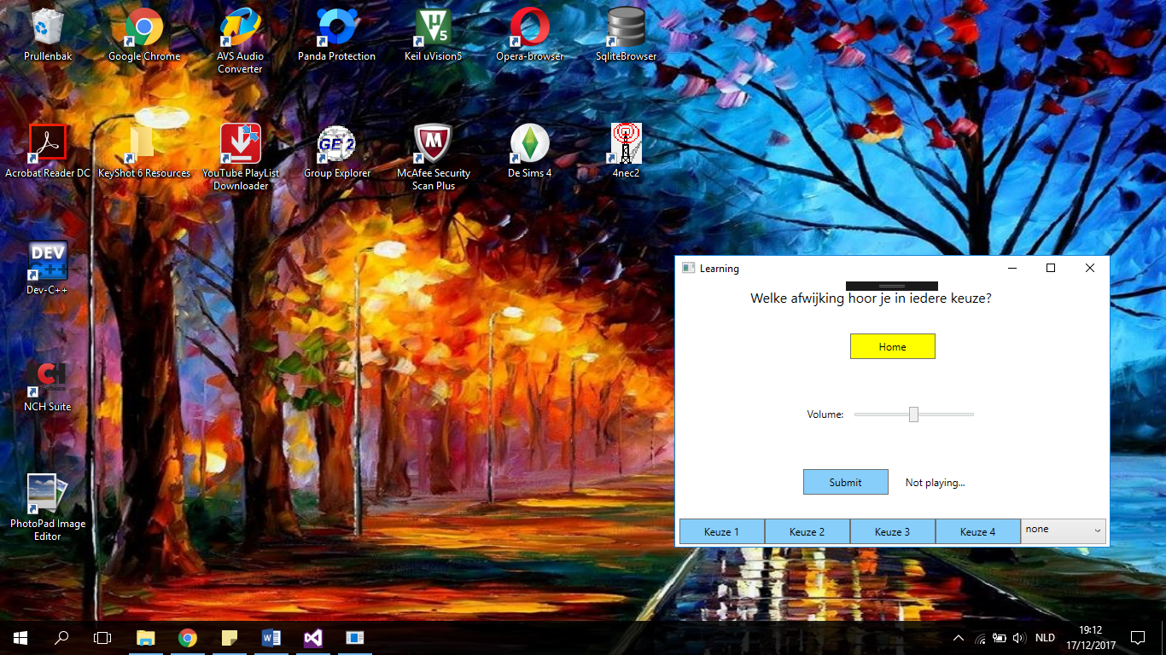

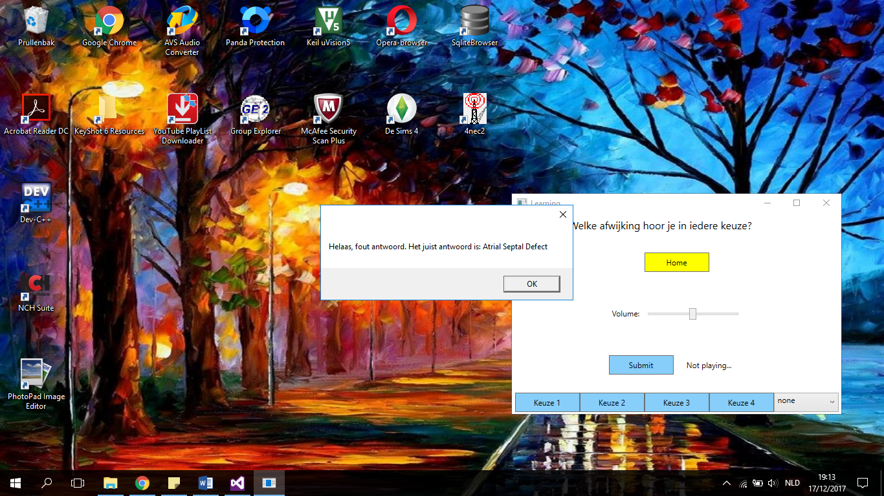

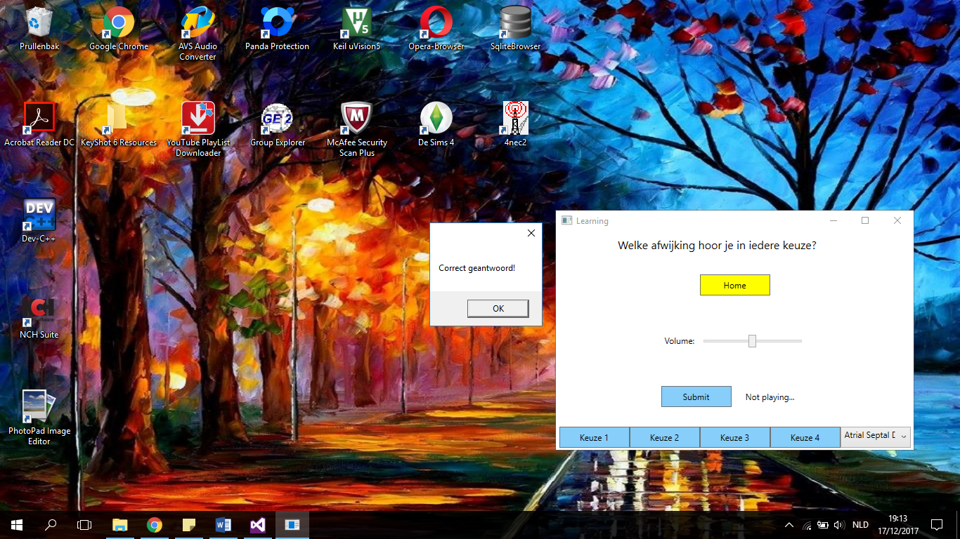

1. Images of the exam session

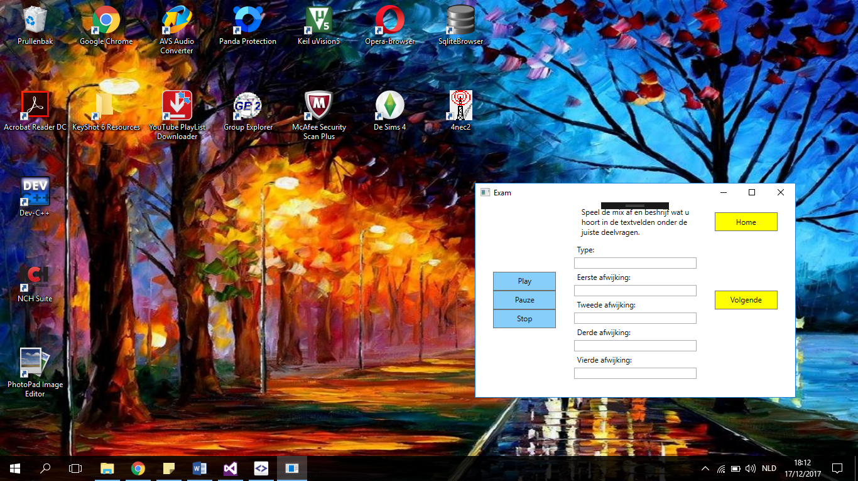

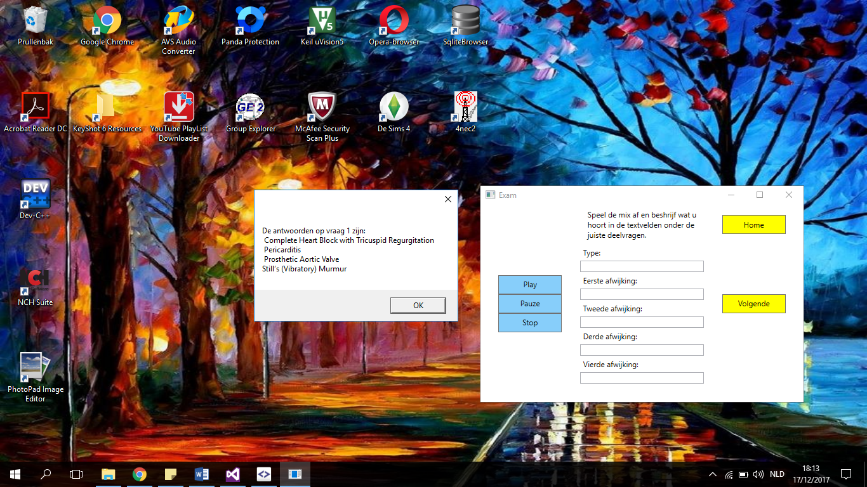

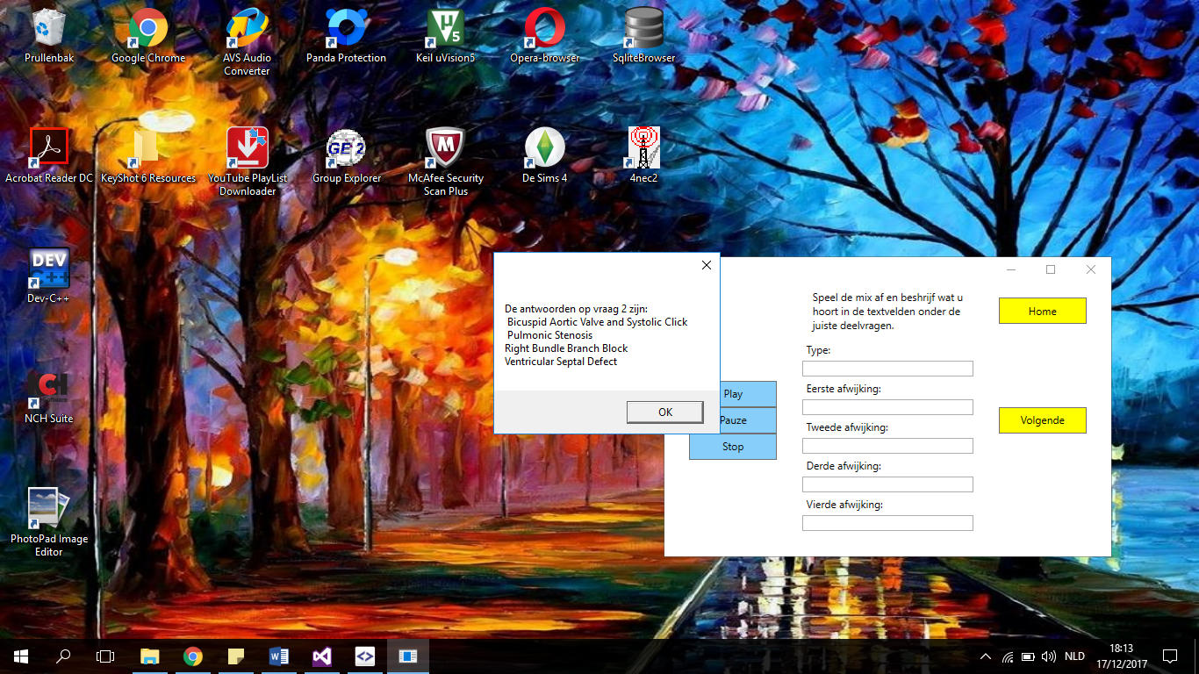

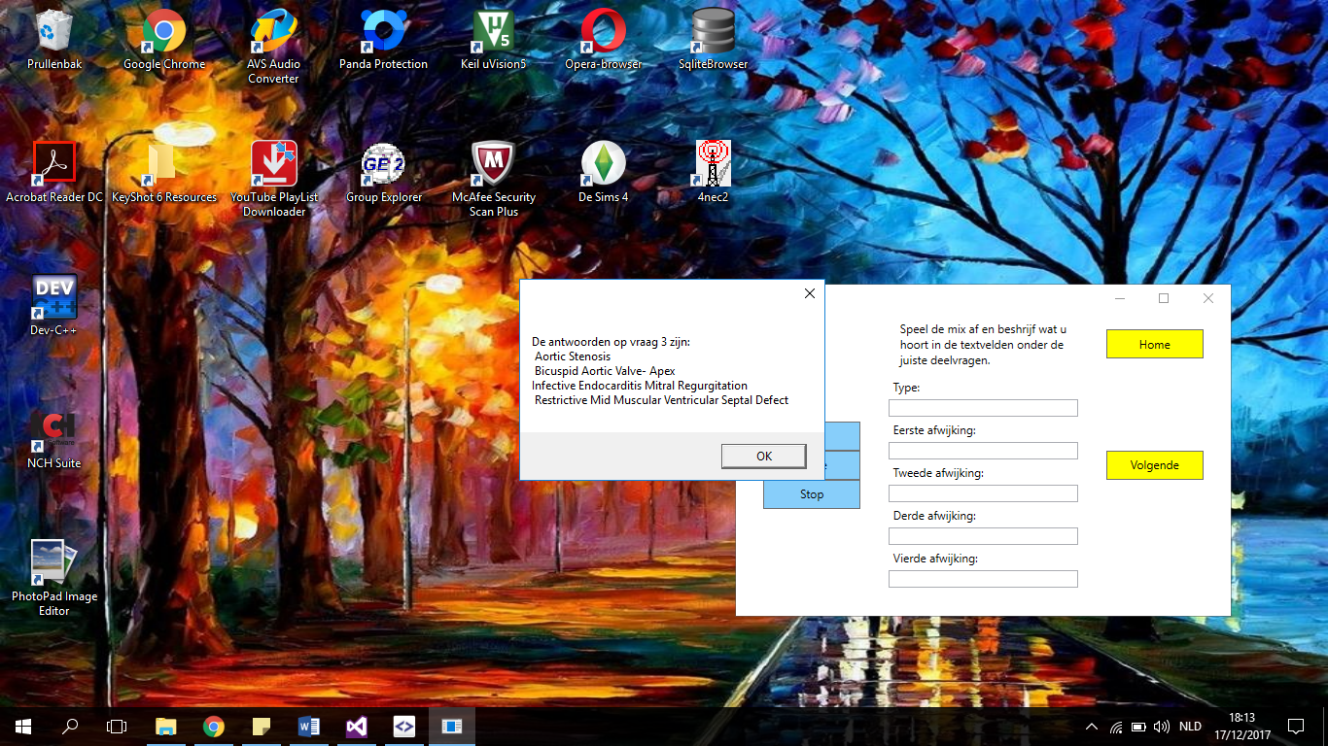

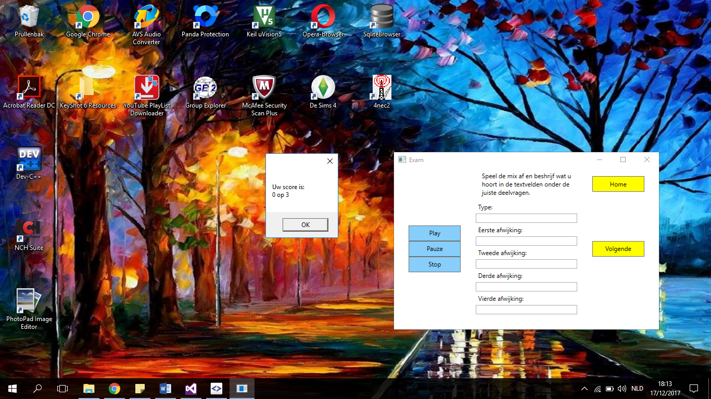

1. Images of the add tab

